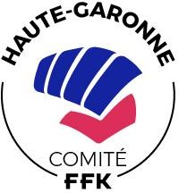

STAGE ARBITRAGE

BODY KARATE

- Session 2023 -

- Dimanche 5 février 2023 : 9h00 à 12h00 :
- Rappel théorique, règlement compétitions Body Karaté, critères d’arbitrage..
- Pratique sur tatamis, manipulation katop..

https//sites.ffkarate.fr/hautegaronne

FORMULAIRE INSCRIPTION
A retourner à :
cdk.h.garonne.bodykarate.christel@gmail.com

Nom :
Prénom :
Adresse permanente :
Code Postal :
Ville :
Tél. :
Portable :
E mail : @

Numéro de licence :
Numéro d’affiliation du club :
Discipline :
Grade : (facultatif)

